2022
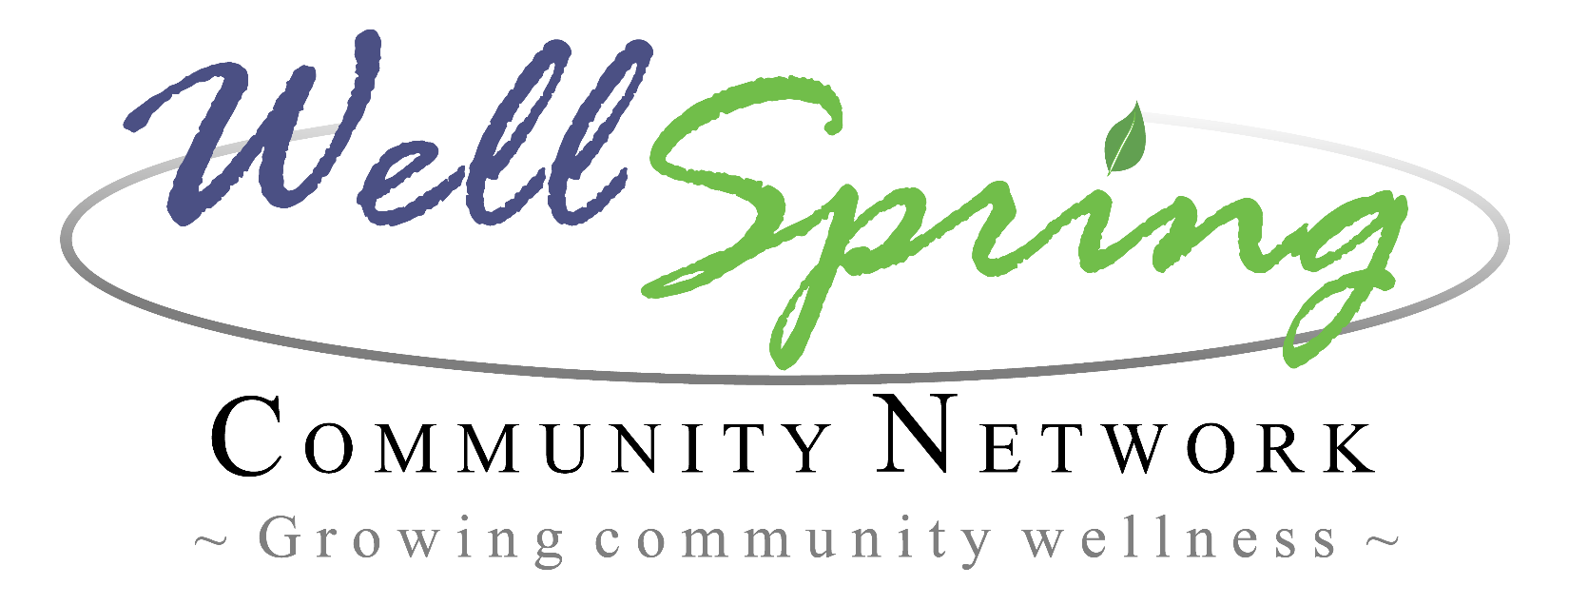
Mini-Grant Application
Please return completed application by 11:59 PM:
Friday, December 16, 2022

Submit applications to:

mzilli@trl.org

Attn: Michelle Zilli

If submitting your application digitally is a hardship please send Michelle a quick email, including your contact information and best way to reach you.

Projects we are looking to fund MUST address or have an outcome related to:
Building Resiliency
Some examples may include programs or services that promote positive youth development and support families. Projects in the past have addressed:

Parent Education

Family Enrichment

Food Programs

Literacy

Community Connections

Early Childhood Development

Entrepreneurship and Youth Innovation

Child Abuse and Neglect Prevention

Youth Violence Prevention

Youth Substance Abuse Prevention

Teen Pregnancy Prevention

Mental Health Promotion

Domestic Violence Prevention

School Dropout Prevention

Housing and Homelessness

Grant funding is REIMBURSEMENT ONLY. Scans of original receipts must be submitted for all expenses.

Typical award amounts range from $250 to $1,000 each. Projects must be completed by December 31, 2023. Scans of original receipts, invoices, and reports due within 60 days of completion of project, but no later than January 7, 2022.

2022 Mini-Grant Application
Today’s Date: ___________________ Date of Proposed Project: ___________________
Organization: _____________________________________________________________
Address: _________________________________________________________________
City/State/Zip: ____________________________________________________________
Contact Person: ___________________________________________________________
Phone: __________________________________________________________________
E-mail: __________________________________________________________________
We are a:
______ Non-profit ______ School-based group
______ Faith-based group/organization ______ Local Government
______ Community-based group/organization ______ Tribal organization
______ Community Member/Volunteer ______ Other______________________
If the organization listed above is not acting as its own fiscal agent please indicate what organization/individual will be processing the funds.
Organization: ____________________________________________________
Address: ________________________________________________________
City/State/Zip: ___________________________________________________
Contact Person: _________________________________________________
Phone: _________________________________________________________
E-mail: _________________________________________________________

Mini-Grant Questionnaire
If necessary, attach answer on a separate page.

- Needs Statement: Provide an outline of the general needs in the community that your project addresses.

- Project Description: In detail, describe the project. Include a project timeline.

- How does your project build resiliency?

- What are the goals and expected outcomes of the project?

- Project Target:
Who is the main demographic of the targeted audience?________________________________________
How many people will be served by the project?______________________________________________
What is the target geographic area?_________________________________________________________

- Collaboration: Describe any plans to collaborate with other community partners.

- Sustainability: What parts of your project are sustainable and how will you ensure that your project's impact in the community will continue after it is complete?

- You will be expected to give an oral presentation on the completed project before reimbursement. (if this presents a hardship please contact the mini grant coordinator)
  - Your presentation will be greatly enhanced if a member of the target group is a participant in the reporting. Please provide the name and contact information for the person responsible for presenting the oral report to Wellspring Community Network?_____________________________________________________________________

BUDGET (Please complete all relevant categories)
BUDGET CATEGORIES | TOTALS
- Materials & Supplies: Please include quantities and price per item | $
- Printing: Please include quantities and price per item | $
- Food: Please include quantities and price per item | $
- Rental fees: Examples: space, equipment, etc. | $
- Travel/Transportation: Estimate travel expenses needed to support the project; using the website below to obtain standard rates for your area.  http://www.gsa.gov/portal/category/21283 | $
- Other Expenses: List any other expenses needed to complete the project. Attach another sheet if necessary. *Please note: wages are not a reimbursable expense. | $
TOTAL AMOUNT NEEDED FOR PROJECT/SUPPLIES | $
If we can’t provide the full funding, what is the minimum dollar amount you would need from us in order to still run the project?* ________________________________________________
Please indicate how the project would be affected if funded at this minimum amount:
____________________________________________________________________________________________________________________________________________________________________________________
*Stating a minimum amount will not hurt your chances of receiving full funding. If we receive a large number of grant requests, we may decide to partially fund as many projects as possible instead of fully funding just a few.
Grant notifications will be announced on or before:
Friday, January 6, 2023
Good Luck!

